**C compiling terminal:**

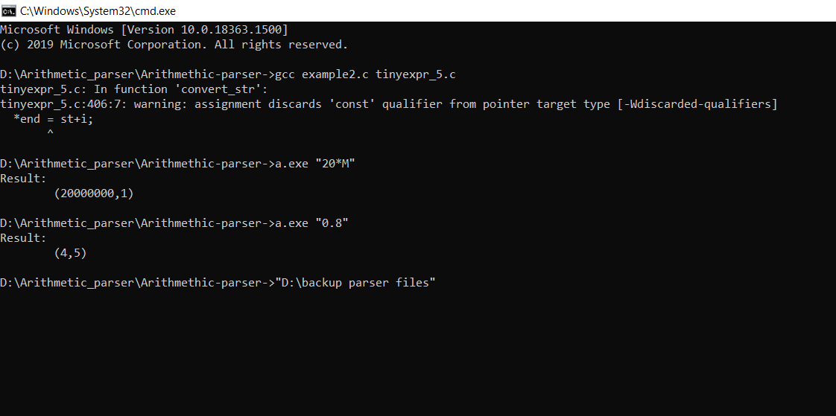

**Python compiling Terminal :** 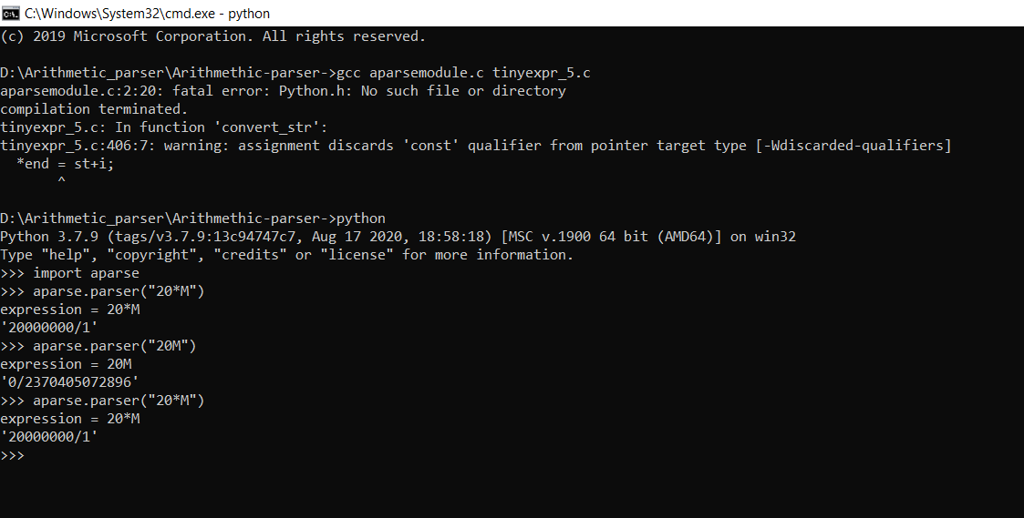

**Convert module:**

* gcc aparsemodule.c tinyexpr_5.c
* where python
* c:\users\kayal\AppData\Local\Programs\Python\python37\python.exe

gcc-Ic:\users\kayal\AppData\Local\Programs\Python\Python37\include\aparsemodule.c tinyexpr_5.c

* python tinyexpr_setup.pyd build